Lab 6.2: Docker Registry with Centos

This section will show you how to work with a Docker registry and run a Docker registry from an official registry image.

This lab has 3 sub-sections:

* + 1. Pull a Centos Linux container
    2. Push the image to the local repository
    3. Run a new image

**Step 6.2.1:** Pull a Centos Linux container

Pull a recent version of the Centos Linux container.

docker pull registry:2

Run the registry in a new Docker container. Expose port 5000.

docker run -d -p 5000:5000 --restart=always --name registry registry:2

Pull another image and store it in the local registry. Pull a new image from Docker hub.

docker pull ubuntu

Tag the image for the local registry.

docker tag ubuntu localhost:5000/ubuntu

**Step 6.2.2:** Push the image to the local registry.

docker push localhost:5000/ubuntu

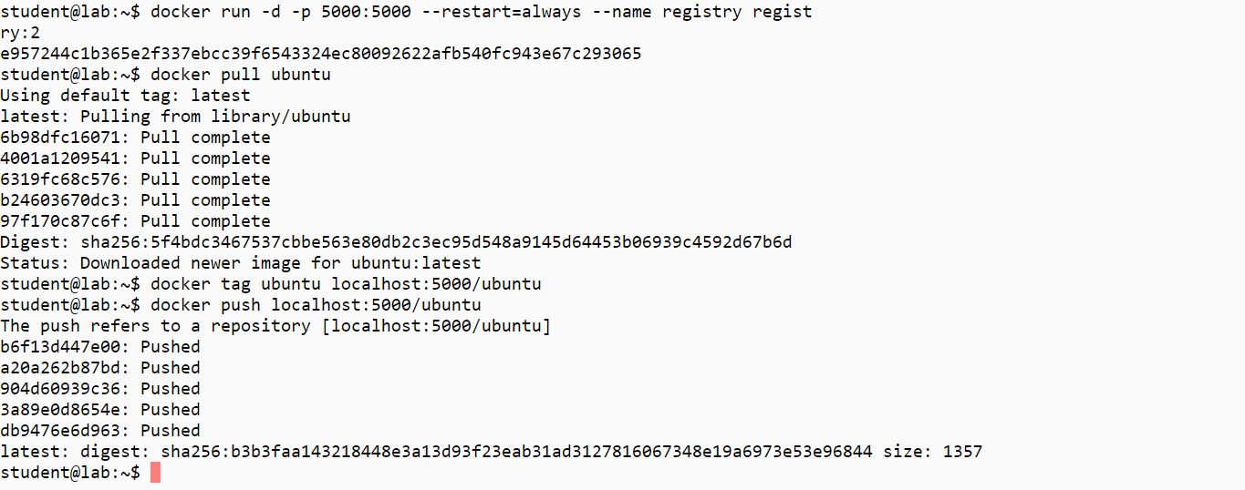

Remove the image from the local cache.

docker rmi ubuntu

Confirm that it has been removed.

docker images

**Step 6.2.3:** Run a new image

Pull the image from the local registry.

docker pull localhost:5000/ubuntu

Confirm it is in the local cache.

docker images

Run the new image.

docker run -it --rm localhost:5000/ubuntu /bin/bash

Exit the container.

exit

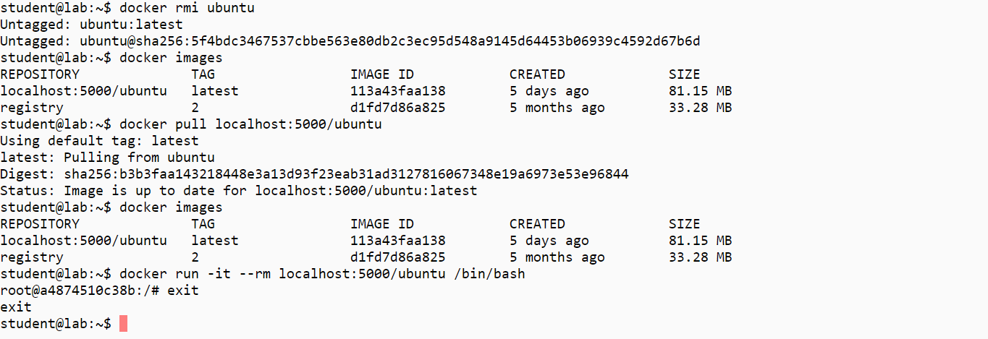

Clean up artifacts from the lab.

docker rm -f $(docker ps -aq)  
docker rmi $(docker images -q)